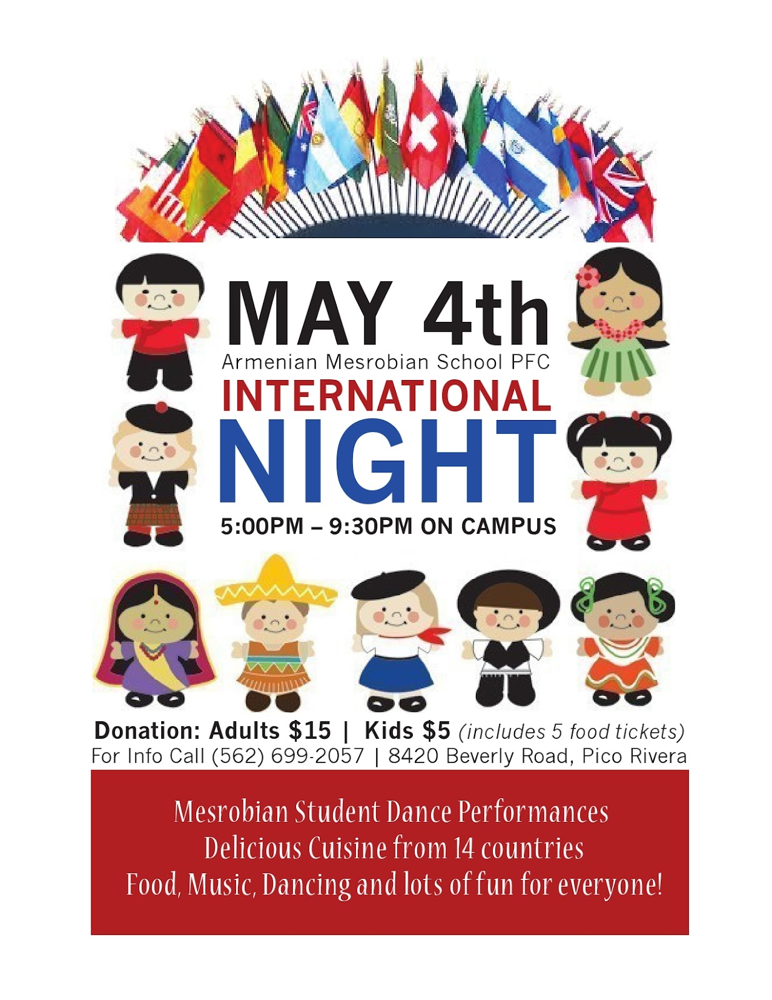

***Student Performances.***

***Delicious Cuisine from different countries.***

***Food, Music, Dancing and lots of fun for everyone!***

***Volunteers needed.***

Friday, May 4th, 6:30-8:30 PM, TRES cafeteria and gym.

13400 Triadelphia Rd, Ellicott City, MD 21042.

Contact: Jing Tian (jtian@hotmail.com)

May 4th 2018

**Triadelphia Ridge Elementary School**